SIMATS ENGINEERING
ASSESSMENT TOOL 1
Experiments

STUDENT NAME: G. Padma Bhindya
Reg.No:192565049
COURSE NAME: Computer Networks COURSE CODE: CSA0706

COURSE OUTCOME COVERED

CO3: Analyze the performance of core network protocols such as TCP, UDP, HTTP, and DNS under varying conditions
Assessment Tool Weightage: 40%
SOFTWARE: CISCO PACKET TRACER, WIRESHARK

EXPERIMENTS

QUESTIONS:4 Total Marks:40

- Design a simple LAN consisting of two PCs connected through a switch using Cisco Packet Tracer. Configure appropriate IP addresses for both hosts and verify connectivity using the ping command. Simultaneously capture the packet exchange using Wireshark. Identify the Ethernet frame fields such as Source MAC Address, Destination MAC Address, EtherType, and Frame Check Sequence (FCS). Explain how the Data Link layer uses MAC addressing to ensure successful frame delivery within the local network.
- Create a network topology consisting of two LANs connected through a router in Cisco Packet Tracer. Configure IPv4 addressing, subnet masks, and default gateways for all devices, and verify end-to-end communication using the ping command. Capture the ICMP packets using Wireshark and analyze the IPv4 header fields, including Source IP Address, Destination IP Address, Time-To-Live (TTL), Protocol Number, and Header Length. Explain the role of the Network layer in forwarding packets between different networks.
- Construct a local area network with multiple hosts connected through a switch in Cisco Packet Tracer. Clear the ARP cache on one of the hosts and initiate communication with another host using the ping command. Capture the communication in Wireshark and identify the ARP Request and ARP Reply packets. Analyze the sender and target MAC/IP addresses and explain how the Address Resolution Protocol resolves logical IP addresses into physical MAC addresses before data transmission.
- Develop a simple network consisting of two PCs connected through a router in Cisco Packet Tracer. Configure the required IP addresses and test connectivity using the ping command. Capture the ICMP traffic using Wireshark and identify the Echo Request and Echo Reply messages. Examine important ICMP fields such as Type, Code, Identifier, and Sequence Number, and calculate the Round Trip Time (RTT). Discuss how ICMP assists in network troubleshooting and connectivity verification.
- Create a client-server network in Cisco Packet Tracer by configuring a web server and a client PC. Enable the HTTP service on the server and access the hosted webpage from the client using a web browser. Capture the communication in Wireshark and identify the TCP three-way handshake, followed by the HTTP GET request and HTTP response messages. Analyze the application-layer communication and explain how TCP provides reliable delivery for HTTP traffic through connection establishment, acknowledgments, and ordered data transfer.

RUBRICS FOR CALCULATION

Criteria | Weightage | Level 4 – Exemplary | Level 3 – Proficient | Level 2 – Developing | Level 1 – Beginning
Understanding of Concepts | 25 | Demonstrates thorough understanding and effectively integrates multiple concepts/technologies | Good understanding with proper integration of most concepts | Basic understanding; limited or partial integration | Poor understanding; unable to integrate concepts
Experimental Design | 30 | Well-planned, systematic implementation with optimal solution | Correct implementation with minor issues | Basic implementation with errors or inefficiencies | Incorrect or incomplete implementation
Use of Tools | 20 | Effective and advanced use of tools/technologies with proper configuration | Appropriate use of tools with correct execution | Limited or inconsistent use of tools | Incorrect or minimal use of tools
Analysis of Results | 15 | Insightful analysis with accurate interpretation and validation of results | Good analysis with reasonable interpretation | Basic analysis with limited insights | Poor or incorrect analysis of results
Documentation | 10 | Clear, well-structured documentation with diagrams, code, and results | Organized documentation with necessary details | Basic documentation with missing details | Poor or incomplete documentation

Experiment 1: LAN Communication and Ethernet Frame Analysis

Aim
To design a simple LAN using two PCs and a switch, configure IP addresses, verify connectivity using the ping command, and analyze Ethernet frame fields using Wireshark.

Software Required
- Cisco Packet Tracer
- Wireshark

Procedure
- Open Cisco Packet Tracer.
- Place one switch and two PCs.
- Connect both PCs to the switch using Copper Straight-Through cables.
- Configure the IP addresses:
  - PC0: 192.168.1.10 /24
  - PC1: 192.168.1.20 /24
- Open the Command Prompt on PC0.
- Run the command:
ping 192.168.1.20
- Start Wireshark and capture the packets.
- Observe the Ethernet frame fields such as Source MAC, Destination MAC, EtherType, and FCS.

Input
- IP Address (PC0): 192.168.1.10
- IP Address (PC1): 192.168.1.20
- Ping Command:
ping 192.168.1.20
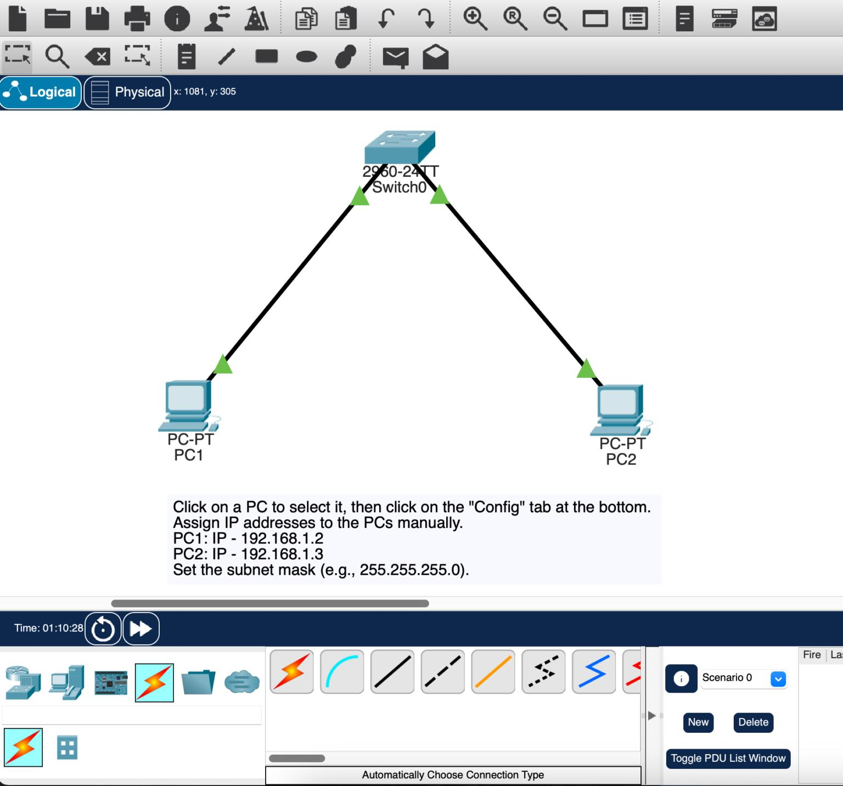

Output
- Ping reply received successfully.
- Wireshark captured Ethernet frames showing:
  - Source MAC Address
  - Destination MAC Address
  - EtherType (IPv4)
  - Frame Check Sequence (FCS)

Result
The LAN was successfully created, communication between the two PCs was verified using the ping command, and the Ethernet frame fields were analyzed in Wireshark.

Experiment 2: Communication Between Two LANs Through a Router

Aim
To connect two LANs through a router, configure IPv4 addressing, and analyze IPv4 header fields using Wireshark.

Software Required
- Cisco Packet Tracer
- Wireshark

Procedure
- Create two LANs with a router between them.
- Configure the following IP addresses:
  - PC0: 192.168.1.10/24
  - Router G0/0: 192.168.1.1/24
  - Router G0/1: 192.168.2.1/24
  - PC1: 192.168.2.10/24
- Set the default gateways on both PCs.
- Open the Command Prompt on PC0.
- Run:
ping 192.168.2.10
- Capture packets using Wireshark.
- Analyze Source IP, Destination IP, TTL, Protocol Number, and Header Length.

Input
- Source IP: 192.168.1.10
- Destination IP: 192.168.2.10
- Ping Command:
ping 192.168.2.10

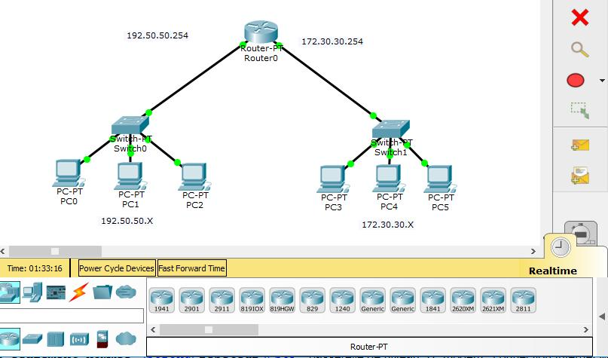

Output
- Successful ping response.
- IPv4 packet captured showing:
  - Source IP Address
  - Destination IP Address
  - TTL
  - Protocol Number (ICMP)
  - Header Length

Result
Communication between two different LANs was established successfully, and the IPv4 header fields were analyzed using Wireshark.

Experiment 3: ARP Protocol Analysis

Aim
To study the Address Resolution Protocol (ARP) by capturing ARP Request and ARP Reply packets using Wireshark.

Software Required
- Cisco Packet Tracer
- Wireshark

Procedure
- Connect two PCs through a switch.
- Configure IP addresses:
  - PC0: 192.168.1.10
  - PC1: 192.168.1.20
- Clear the ARP cache.
- Start Wireshark.
- Ping PC1 from PC0.
- Observe the ARP Request and ARP Reply packets.

Input
- Ping Command:
ping 192.168.1.20
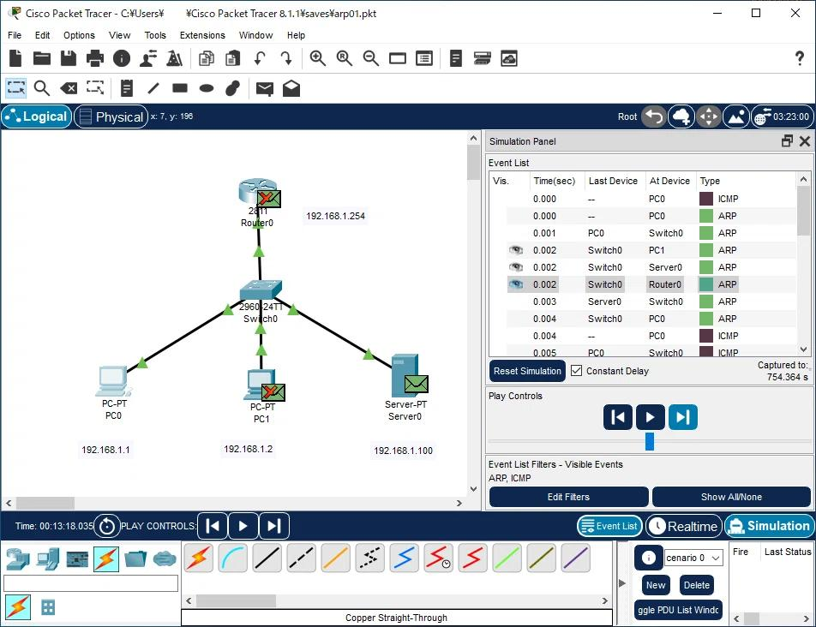

Output
- ARP Request packet captured.
- ARP Reply packet captured.
- Sender and Target IP/MAC addresses displayed.

Result
ARP successfully resolved the destination IP address into a MAC address before communication.

Experiment 4: ICMP Protocol Analysis

Aim
To configure two PCs connected through a router, test communication, and analyze ICMP Echo Request and Echo Reply packets.

Software Required
- Cisco Packet Tracer
- Wireshark

Procedure
- Connect two PCs using a router.
- Configure the IP addresses.
- Configure the router interfaces.
- Open the Command Prompt on PC0.
- Execute:
ping 192.168.2.10
- Capture ICMP packets using Wireshark.
- Observe ICMP Type, Code, Identifier, Sequence Number, and RTT.

Input
- Ping Command:
ping 192.168.2.10
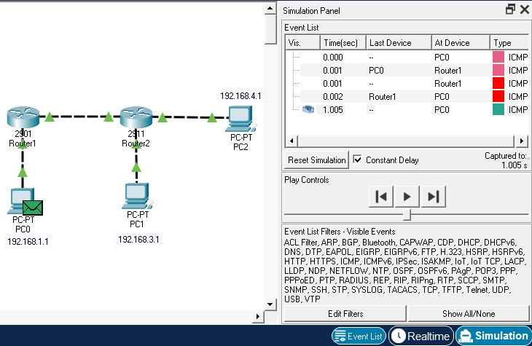

Output
- ICMP Echo Request captured.
- ICMP Echo Reply captured.
- Round Trip Time (RTT) displayed.

Result
ICMP packets were successfully exchanged, verifying network connectivity and enabling network troubleshooting.

Experiment 5: HTTP Communication Using TCP

Aim
To configure a client-server network, enable the HTTP service, access a web page, and analyze TCP and HTTP communication using Wireshark.

Software Required
- Cisco Packet Tracer
- Wireshark

Procedure
- Place one PC and one Server in Cisco Packet Tracer.
- Connect them through a switch.
- Configure IP addresses:
  - Client: 192.168.1.10
  - Server: 192.168.1.20
- Enable the HTTP service on the server.
- Open the Web Browser on the client.
- Enter:
http://192.168.1.20
- Capture packets using Wireshark.
- Observe the TCP three-way handshake and HTTP GET/Response messages.

Input
- URL:
http://192.168.1.20
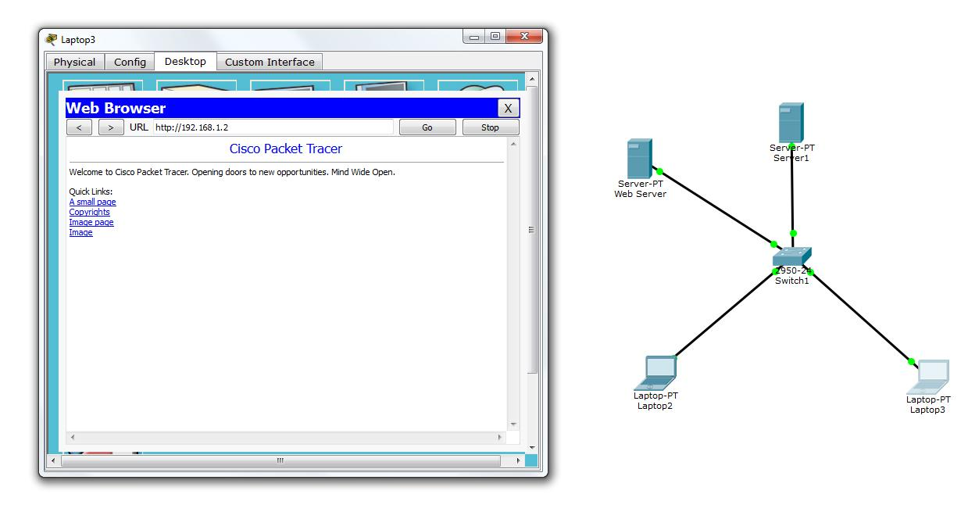

Output
- Web page displayed successfully.
- Wireshark captured:
  - TCP SYN
  - SYN-ACK
  - ACK
  - HTTP GET Request
  - HTTP Response (200 OK)

Result
The client successfully accessed the web server, and TCP connection establishment along with HTTP communication was analyzed using Wireshark.

